**PROJECT REPORT**

**DOCUMENTATION**

**AQUATIC INSIGHTS COGNOS -POWERED**

**WATER PORTABILITY ANALYSIS**

**TEAM ID 442DFBBB9368E6B85704B62343BFF57D**

**DOMAIN**

**DATA ANALYTICS WITH TABLEAU**

**TEAM LEAD : Sucharitha.M TEAM MEMBER 1 : Uthra.T**

**TEAM MEMBER 2 : Vaishnavi.B**

**TEAM MEMBER 3 : Supriyaa.G**

CONTENT

1. **INTRODUCTION**
   1. Project Overview
   2. Purpose
2. **LITERATURE SURVEY**
   1. Existing problem
   2. References
   3. Problem Statement Definition
3. **IDEATION & PROPOSED SOLUTION**
   1. Empathy Map Canvas
   2. Ideation & Brainstorming
4. **REQUIREMENT ANALYSIS**
   1. Functional requirement
   2. Non-Functional requirements
5. **PROJECT DESIGN**
   1. Data Flow Diagrams & User Stories
   2. Solution Architecture
6. **PROJECT PLANNING & SCHEDULING**
   1. Technical Architecture
   2. Sprint Planning & Estimation
   3. Sprint Delivery Schedule
7. **CODING & SOLUTIONING (Explain the features added in the project along with code)**
   1. Feature 1
8. **PERFORMANCE TESTING**
   1. Performace Metrics
9. **RESULTS**
   1. Output Screenshots
10. **ADVANTAGES & DISADVANTAGES**
11. **CONCLUSION**
12. **FUTURE SCOPE**
13. **APPENDIX**
    1. Source Code
    2. GitHub & Project Demo Link

# 1.INTRODUCTION

## PROJECT OVERVIEW:

"Aquatic Insights is a transformative project leveraging IBM Cognos for water portability analysis. It focuses on collecting, cleaning, and standardizing diverse water quality data from various sources. Using Cognos, the project delivers data analytics and reporting, with a user-friendly interface, mobile accessibility, and strong security measures. It promotes collaboration, public awareness, and continuous improvement. Aquatic Insights aims to enhance our understanding of water resources and support sustainable management of aquatic

ecosystems."

## PURPOSE:

The project "Aquatic Insights: Cognos-Powered Water Portability Analysis" aims to use IBM Cognos and advanced analytics for several purposes:

* Assess water quality and portability.
* Integrate diverse data sources for a comprehensive view.
* Standardize data to ensure consistency.
* Provide advanced analytics to identify trends and threats.
* Create a user-friendly platform for data interaction.
* Raise public awareness and offer educational resources.
* Foster collaboration among experts.
* Ensure data security and privacy.

The overarching purpose is to improve understanding and facilitate sustainable management of aquatic ecosystems for the benefit of researchers,

policymakers, and the public.

# 2.LITERATURE SURVEY

## Existing problem:

In the literature survey for the project "Aquatic Insights: Cognos-Powered Water Portability Analysis," several existing issues are identified:

* + - Limited data integration from diverse sources.
    - Challenges in data standardization and consistency.
    - Lack of predictive modeling for water quality trends.
    - Poor accessibility and user-friendliness.
    - Limited collaboration among stakeholders.
    - Insufficient mobile accessibility for on-the-go access.
    - Inadequate attention to data security and privacy.
    - Limited emphasis on public awareness and education.
    - Gaps in regulatory compliance.
    - Potential issues with outdated information.

Addressing these problems is crucial for the project's success, ensuring it

provides valuable and up-to-date insights into water quality and portability for a wide range of users and stakeholders.

## References:

## • Carpenter, S. R., & Cottingham, K. L. (1997). Resilience and water quality. Ecology, 78(3), 899-904.

## • Jin, X., Yang, Z., & Han, H. (2019). A review on predicting algal blooms in freshwater lakes using satellite remote sensing.

Environmental Science and Pollution Research, 26(19), 19513- 19530.

• Cognos Analytics Documentation. IBM. [Link to official IBM Cognos documentation for technical reference and usage.]

• Ouyang, W., & Bartholic, J. (2009). Application of the Soil and Water Assessment Tool (SWAT) for water quality research: A review. Journal of Environmental Quality, 38(2), 515-523.

* 1. **Problem Statement Definition:**

The problem statement for "Aquatic Insights: Cognos-Powered Water Portability Analysis" centers on addressing several key challenges in water quality assessment and management:

* + - Fragmented data sources and inconsistent data hinder comprehensive analysis.
    - Current methods lack predictive modeling for anticipating water quality trends.
    - Inadequate accessibility and user-friendliness limit information dissemination.
    - Collaboration among experts and stakeholders needs improvement.
    - Mobile accessibility for on-the-go access is lacking.
    - Data security and privacy concerns pose risks.
    - Public awareness and education about water quality are often insufficient.
    - Regulatory compliance gaps and legal issues may arise.
    - Environmental conditions change, requiring continuous updates.

The project aims to resolve these issues by creating a user-friendly, data-driven platform for understanding and managing water quality and portability in aquatic ecosystems.

# 3.IDEATION & PROPOSED SOLUTION

## Empathy Map Canvas:

An empathy map is a simple, easy-to-digest visual that captures knowledge about a user’s behaviours and attitudes.

It is a useful tool to helps teams better understand their users.

Creating an effective solution requires understanding the true problem and the person who is experiencing it. The exercise of creating the map helps participants consider things from the user’s perspective along with his or her goals and challenges.

**Example:**

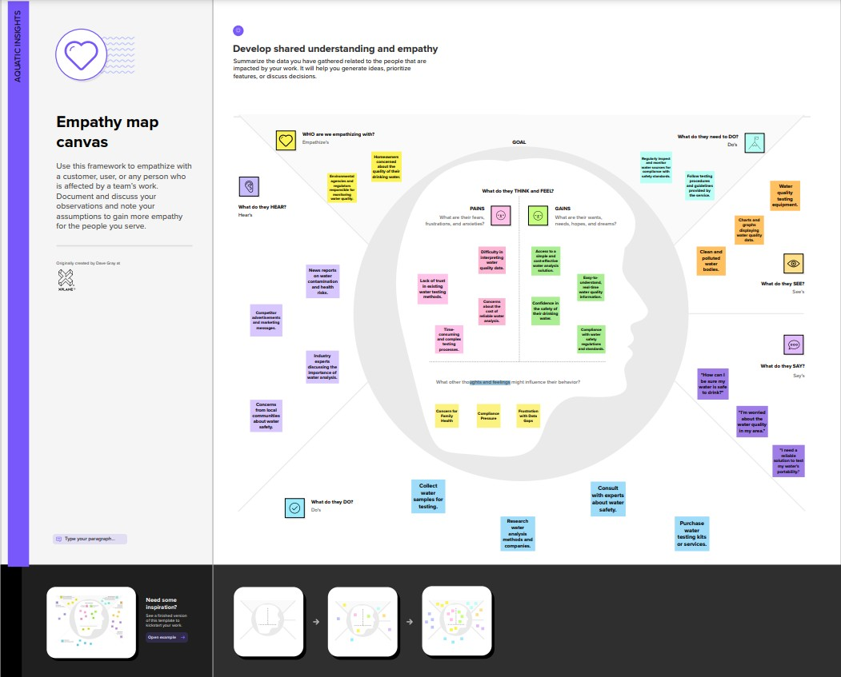

## Ideation & Brainstorming:

Brainstorming provides a free and open environment that encourages everyone within a team to participate in the creative thinking process that leads to problem solving. Prioritizing volume over value, out-of-the-box ideas are welcome and built upon, and all participants are encouraged to collaborate, helping each other develop a rich amount of creative solutions.

Use this template in your own brainstorming sessions so your team can unleash their imagination and start shaping concepts even if you're not sitting in the same room.

**Step-1: Team Gathering, Collaboration and Select the Problem Statement**

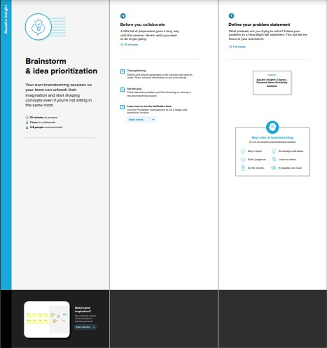

**Step-2: Brainstorm, Idea Listing and Grouping**

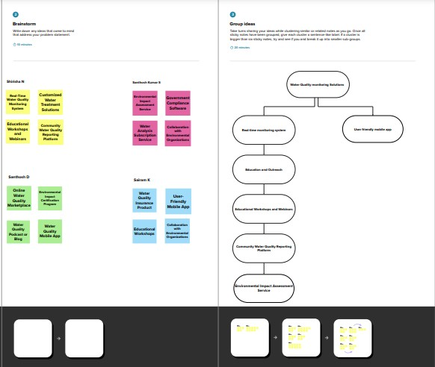

**Step-3: Idea Prioritization**

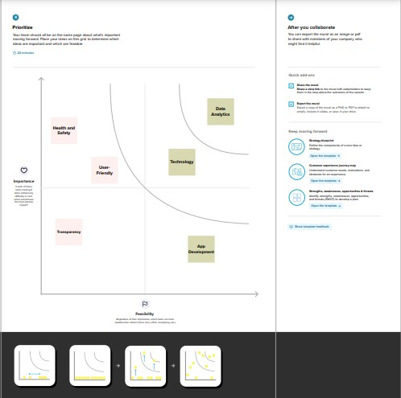

# 4.REQUIREMENT ANALYSIS

## Functional requirement:

The functional requirements for "Aquatic Insights: Cognos-Powered Water Portability Analysis" outline the specific features and capabilities the project's platform should possess. These requirements include:

* + - Data integration and management from various sources.
    - Data standardization for consistency.
    - Analytics and predictive modeling for water quality assessment.
    - Interactive dashboards for data visualization.
    - User profiles and access control.
    - Development of a mobile application.
    - Collaboration tools for experts.
    - Strong data privacy and security measures.
    - Reporting and alerts for critical events.
    - Public engagement and education features.
    - Continuous platform improvement.
    - Regulatory compliance.
    - Scalability and performance for handling large data volumes and users.

These requirements serve as the basis for creating a comprehensive and user- friendly platform for analyzing and managing water quality and portability in aquatic ecosystems.

## Non-Functional requirements:

The non-functional requirements for "Aquatic Insights: Cognos-Powered Water Portability Analysis" outline the performance, reliability, usability, security, and compliance standards that the platform should meet. Key points include:

* + - Fast performance and scalability to handle growth.
    - High reliability and data protection mechanisms.
    - Intuitive user interface and accessibility for all users.
    - Robust security and data privacy measures.
    - Interoperability with other systems.
    - Easy maintenance and regular updates.
    - Compliance with regulations and standards.
    - Load handling during peak events.
    - Data archiving and user support.

These non-functional requirements ensure the platform's effectiveness, user experience, and adherence to legal and environmental standards.

# 5.PROJECT DESIGN

## Data Flow Diagrams & User Stories:

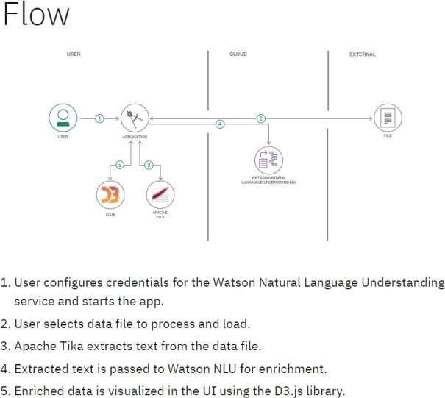

A Data Flow Diagram (DFD) is a traditional visual representation of the information flows within a system. A neat and clear DFD can depict the rightamount of the system requirement graphically. It shows how data enters and leaves the system, what changes the information, and where data is stored.

## Flow diagram:

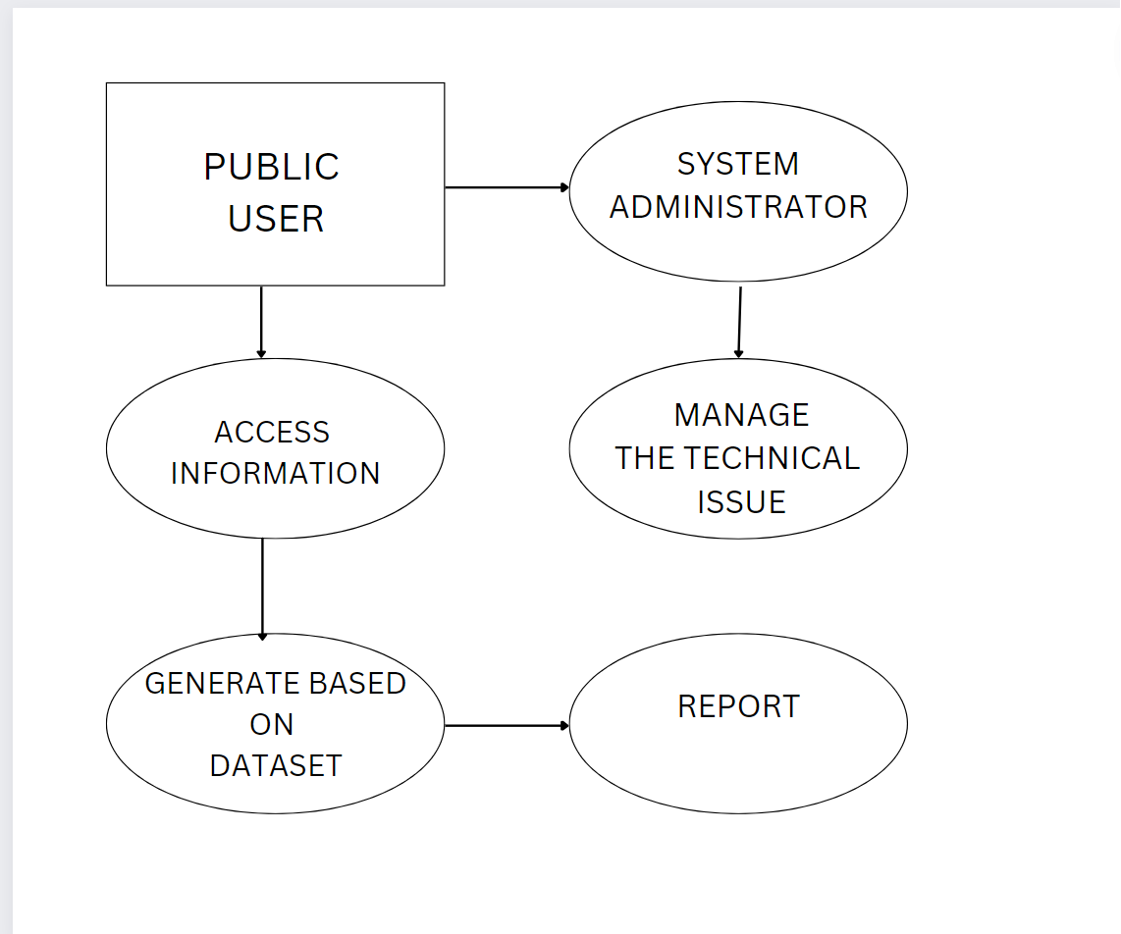

## User Stories:

|  |  |  |  |  |  |  |
| --- | --- | --- | --- | --- | --- | --- |
| **User Type** | **Functional Requiremen t (Epic)** | **User Story Numb er** | **User Story / Task** | **Acceptance criteria** | **Priority** | **Release** |
| PUBLIC | check water quality information for their area | USN-1 | Public users can access the system to check the quality of water in their area. They can view real-time water quality information, including  potability status. | I can access my account / dashboard | o/1 |  |
|  |  | USN-2 | Public users may set preferences to receive real- time alerts and notifications about water quality issues, such as water contamination or safety  concerns. |  | 0/1 |  |
|  |  | USN-3 | They can access historical water quality data to track changes and trends in  water quality over time |  | 0/1 |  |
|  | Dashboard |  |  |  |  |  |
| System Administrator |  |  | Infrastructure Management: System administrators are responsible for managing the technical infrastructure, including servers, databases, and software updates.  They ensure that the system is running smoothly and efficiently. |  |  |  |

* 1. **Solution Architecture:**

Solution architecture is a complex process – with many sub-processes – that bridgesthe gap between business problems and technology solutions. Its goals are to:

* + - * Find the best tech solution to solve existing business problems.
      * Describe the structure, characteristics, behavior, and other aspects of thesoftware to project stakeholders.
      * Define features, development phases, and solution requirements.
      * Provide specifications according to which the solution is defined, managed,and delivered.

Example - Solution Architecture Diagram**:**

Aquatic Insights: Cognos -Powered Water Portability Analysis

User

DATABASE

ADMINISTRATION

Make Decision

Generate Report

Access

Information

STORE

INFORMATION

UPDATE RESULT

**6.PROJECT PLANNING & SCHEDULING**

## Technical Architecture:

The Deliverable shall include the architectural diagram as below and the information as per the table1 & table 2

**Reference: https://**[**www.kaggle.com/code/khsamaha/potable-water-prediction-0-798-**](http://www.kaggle.com/code/khsamaha/potable-water-prediction-0-798-) **with-caret-rf-r/input**

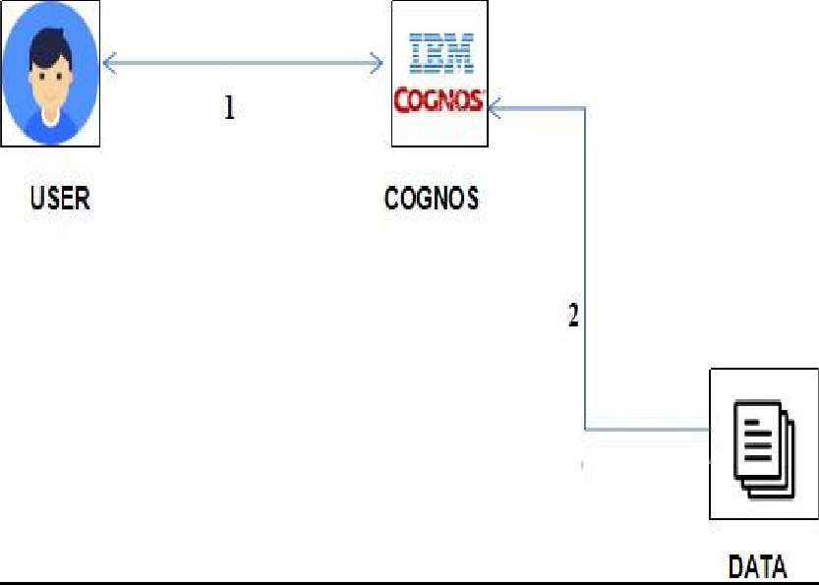

* **Components & Technologies:**

|  |  |  |  |
| --- | --- | --- | --- |
| **S.No** | **Component** | **Description** | **Technology** |
| 1. | User Interface | How user interacts with application  e.g. Web UI, Mobile App, Chatbot etc. | HTML, CSS,  JavaScript / Angular Js / React Js etc. |
| 2. | Application Logic-1 | Logic for a process in the application | Python |
| 3. | Application Logic-2 | Logic for a process in the application | IBM Cognos Analytics |
| 4. | Application Logic-3 | Logic for a process in the application | IBM Cognos Analytics |
| 5. | Database | Data Type, Configurations etc. | Excel |

|  |  |  |  |
| --- | --- | --- | --- |
| 6. | Cloud Database | Database Service on Cloud | IBM DB2, IBM  Cloudant etc. |
| 7. | File Storage | File storage requirements | IBM Block Storage or Other Storage Service or Local  Filesystem |
| 8. | External API-1 | Purpose of External API used in the application | IBM Weather API, etc. |
| 9. | External API-2 | Purpose of External API used in the application | Aadhar API, etc. |
| 10. | Machine Learning Model | Purpose of Machine Learning Model | Object  Recognition Model, etc. |
| 11. | Infrastructure (Server / Cloud) | Application Deployment on Local System / Cloud  Local Server Configuration: Cloud Server Configuration : | Local, Cloud Foundry,  Kubernetes, etc. |

## Sprint Planning & Estimation:

|  |  |  |  |  |  |  |
| --- | --- | --- | --- | --- | --- | --- |
| **Sprint** | **Functional Requirement (Epic)** | **User Story Number** | **User Story / Task** | **Story Points** | **Priority** | **Team Members** |
| Sprint-1 | Registration | USN-1 | As a user, I can register for the application by entering my email, password, and confirming my password. | 2 | High |  |
| Sprint-1 |  | USN-2 | As a user, I will receive confirmation email once I have registered for the  application | 1 | High |  |
| Sprint-2 |  | USN-3 | As a user, I can register for the application through SmartInternz | 2 | Low |  |
| Sprint-1 |  | USN-4 | As a user, I can register for the application through smartInternz provided email id. | 2 | Medium |  |
| Sprint-1 | Login | USN-5 | As a user, I can log into the application by entering email & password | 1 | High |  |
|  | Dashboard |  |  |  |  |  |

* + - 1. **Sprint Delivery Schedule:**

|  |  |  |  |  |  |  |
| --- | --- | --- | --- | --- | --- | --- |
| **Sprint** | **Total Story Points** | **Duration** | **Sprint Start Date** | **Sprint End Date (Planned)** | **Story Points**  **Completed (as on Planned End Date)** | **Sprint Release Date (Actual)** |
| Sprint-1 | 20 | 1 Days | 16 Oct 2023 | 16 Oct 2023 | 16 Oct 2023 | 16 Oct 2023 |
| Sprint-2 | 20 | 1 Days | 17 Oct 2023 | 17 Oct 2023 | 17 Oct 2023 | 17 Oct 2023 |
| Sprint-3 | 20 | 1 Days | 18 Oct 2023 | 18 Oct 2023 | 18 Oct 2023 | 18 Oct 2023 |
| Sprint-4 | 20 | 1 Days | 19 Oct 2023 | 19 Oct 2023 | 19 Oct 2023 | 1. Oct 2023 |

# 7.CODING & SOLUTIONING

## 7.1. Feature 1:

<!DOCTYPE html>

<html lang="en">

<head>

<meta charset="UTF-8">

<meta name="viewport" content="width=<device-width>, initial-scale=1.0">

<title> Water Portable </title>

<style> body{

background-color: rgb(0, 0, 0);

}

h1{

text-align: center; font-size:50px;

}

p{

font-size: 25px; font-style: italic; font-weight: 100; margin-left: 20px;

}

</style>

</head>

<body>

<h1 style="font-size: 40px;color: rgb(255, 255, 255);"><b>Aquatic Insights</b></h1> <h1 style="font-size: 40px;color: rgb(255, 255, 255);"><b>COGNOS POWERED</b></h1> <h1

style="font-size: 40px;color: rgb(255, 255, 255);"><b>WATER PORTABILITY ANALYSIS</b></h1>

<h2 style="font-size: 25px;color: rgb(255, 255, 255);">Here is the data analyst regarding the water analysis. We are analysed with the different datas like ph values , Hardness , TDS , Chloramines

, Sulfate , Conductivity , Organic carbon , Trihalomethanes , Turbidity , Potability of the water samples.</h2>

<iframe src="https://us3.ca.analytics.ibm.com/bi/

perspective=dashboard&amp;pathRef=.public_folders%2FProject

2FDashboard_water&amp;closeWindowOnLastView=true&amp;ui_appbar=false&amp;ui_navbar=fal se&amp;shareMode=embedded&amp;action=view&amp;mode=dashboard&amp;subView=model00 00018b452f8bbd_00000000" width="800" height="800" frameborder="0" gesture="media"

allow="encrypted-media" allowfullscreen=""></iframe>

<h1 style="font-size: 40px;color: rgb(255, 255, 255);">STORY BOARD</h1>

<p style="font-size: 29px;color: rgb(255, 255, 255);"><!--stry goes here-->Our Analysis are Seperate the Samples as Portable and Non Portable , Average Sulphate content of portable and non portable , Summerizing cloramines taking their average , Summerizing Organic - Carbon content taking their average , Average Organic- Corbon content of portable and non-portable water ,

Chloramines by Conductivity (Group) colored by Potability and ph by Hardness (Group) colored by Potability. </p>

<iframe

src="https://us3.ca.analytics.ibm.com/bi/?perspective=story&amp;pathRef=.public_folders%2FProje ct%2FStory%2Bof%2BWater%2Bpotability&amp;closeWindowOnLastView=true&amp;ui_appbar=fals e&amp;ui_navbar=false&amp;shareMode=embedded&amp;action=view&amp;sceneId=model0000 018b4795eed0_00000000&amp;sceneTime=3350" width="800" height="800" frameborder="0"

gesture="media" allow="encrypted-media" allowfullscreen=""></iframe>

</body>

</html>

# 8.PERFORMANCE TESTING

**8.1. Performace Metrics:**

|  |  |  |
| --- | --- | --- |
| **S.No.** | **Parameter** | **Screenshot / Values** |
| 1. | Dashboard design | No of Visualizations / Graphs – We have include 4 tabs |
| 2. | Data Responsiveness | The system's ability to efficiently analyze these indicators and provide real-time predictions, ensuring the availability of safe drinking water in regions facing a crisis |
| 3. | Amount Data to Rendered (DB2 Metrics) | The global drinking water crisis by ensuring the availability of safe and potable water in regions facing water quality concerns |
| 4. | Utilization of Data Filters | Employed to narrow down the dataset and focus the analysis such as assess water quality |
| 5. | Effective User Story | No of Scene Added - 4 |
| 6. | Descriptive Reports | No of list / Graphs – 1 |

# 9.RESULTS

**9.1. Output Screenshots:**

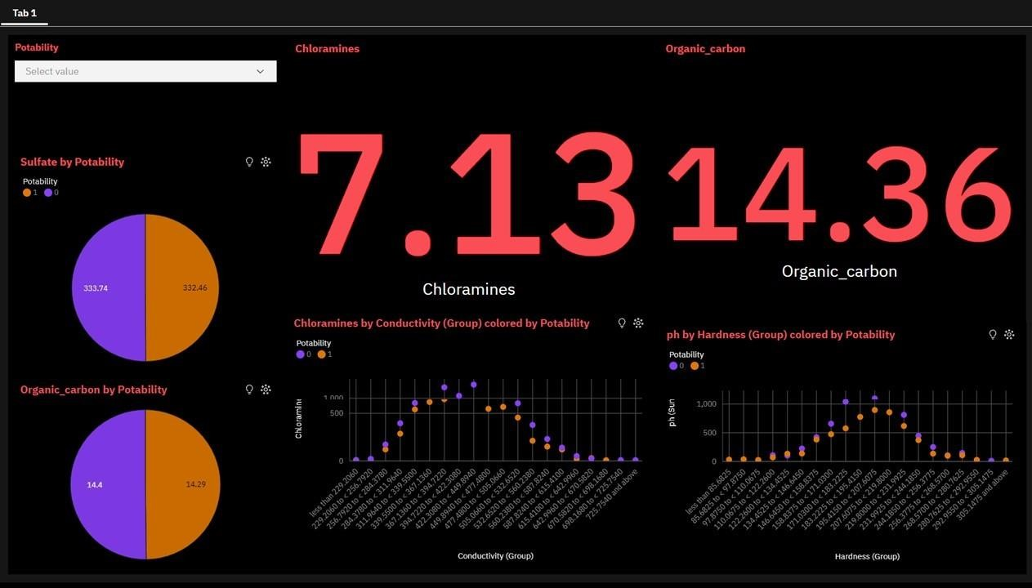

**10.ADVANTAGES & DISADVANTAGES**

## Advantages:

The project "Aquatic Insights: Cognos-Powered Water Portability Analysis" offers a range of advantages:

* + Comprehensive water quality assessment with predictive capabilities.
  + User-friendly interface accessible to experts and the public.
  + Data integration for a complete view of water quality.
  + Facilitation of collaboration and knowledge sharing.
  + Promotion of public awareness and regulatory compliance.
  + Robust data security and continuous improvements.
  + Resource efficiency and environmental sustainability.
  + Data-driven decision-making for policymakers and researchers.
  + Customization and scalability for future growth.
  + Real-time monitoring and international collaboration.

These advantages collectively contribute to improved water quality management and sustainable ecosystems.

## Disadvantages:

The project "Aquatic Insights: Cognos-Powered Water Portability

Analysis" comes with several potential disadvantages and challenges:

* + Handling complex and diverse data sources.
  + Data availability limitations in remote or less-studied areas.
  + Technical barriers for some users with limited skills.
  + Ongoing maintenance and software update costs.
  + Stringent data privacy and security requirements.
  + Regulatory compliance complexities.
  + Resource-intensive computational and human requirements.
  + High initial implementation costs.
  + Sustaining user engagement and public awareness.
  + Ensuring data consistency across various sources.
  + Adaptation to changing environmental conditions.
  + Potential public resistance to sharing data.
  + Mobile application compatibility challenges.
  + Scalability concerns as the project grows.
  + Effective communication with diverse stakeholders.

Mitigating these challenges will be vital for the project's success and its ability to deliver comprehensive water quality insights.

# 11.CONCLUSION

In conclusion, "Aquatic Insights: Cognos-Powered Water Portability Analysis" represents a promising solution for addressing challenges in water quality assessment and management. The project leverages advanced data analytics, user-friendly interfaces, and collaboration tools to provide valuable insights

into aquatic ecosystems. It offers advantages such as improved water quality assessment and informed decision-making, contributing to environmental sustainability.

Despite potential challenges such as data complexity and privacy concerns, the project's goals are attainable with careful planning and dedication. "Aquatic Insights" has the potential to be a valuable resource for various stakeholders, serving as a catalyst for positive change in aquatic ecosystem management. The project signifies a promising path toward sustainable water quality

management and the preservation of natural water resources.

# 12.FUTURE SCOPE

The future scope for "Aquatic Insights: Cognos-Powered Water Portability Analysis" is expansive and promising. It includes:

* Incorporating advanced data sources, AI, and IoT for more comprehensive and real-time water quality analysis.
* Implementing blockchain for enhanced data security and transparency.
* Facilitating global collaboration and data sharing.
* Developing educational resources and influencing water quality policies.
* Addressing climate change and ecosystem health, and expanding the project's focus to include flood monitoring and environmental equity.77
* Promoting sustainable practices and contributing to open data initiatives.

The project has the potential to become a comprehensive and collaborative platform, empowering stakeholders to better understand and manage aquatic ecosystems in an increasingly complex world.

# 13.APPENDIX

## Source Code:

### Index.html

<!DOCTYPE html>

<html lang="en">

<head>

<meta charset="UTF-8">

<meta name="viewport" content="width=device-width, initial-scale=1.0">

<title>Water Portable</title>

<style>

body {

background-color: rgb(0, 0, 0);

}

h1 {

text-align: center;

font-size: 50px;

color: rgb(255, 255, 255);

}

h2 {

font-size: 25px;

color: rgb(255, 255, 255);

}

p {

font-size: 29px;

color: rgb(255, 255, 255);

}

.center-img {

text-align: center;

}

.center-img img {

display: block;

margin: 0 auto;

max-width: 100%; /* Ensure images don't exceed their container width */

}

</style>

</head>

<body>

<h1><b>Aquatic Insights</b></h1>

<h1><b>COGNOS POWERED</b></h1>

<h1><b>WATER PORTABILITY ANALYSIS</b></h1>

<h2>Here is the data analysis regarding water analysis. We have analyzed various data points such as pH values, hardness, TDS, chloramines, sulfate, conductivity, organic carbon, trihalomethanes, turbidity, and potability of the water samples.</h2>

<div class="center-img">

<img id="image1" src="C:/Users/murar/OneDrive/Desktop/NM/FINAL DELIVERABLES/templates/pic 1.png">

</div>

<h1>STORY BOARD</h1>

<p>Our analysis separates the samples as portable and non-portable, averages sulfate content for portable and non-portable water, summarizes chloramines taking their average, summarizes organic carbon content taking their average, and considers the average organic carbon content of portable and non-portable water. We also look at chloramines by conductivity (group) colored by potability and pH by hardness (group) colored by potability.</p>

<div class="center-img">

<img id="image2" src="C:/Users/murar/OneDrive/Desktop/NM/FINAL DELIVERABLES/templates/pic 2.png">

<img id="image3" src="C:/Users/murar/OneDrive/Desktop/NM/FINAL DELIVERABLES/templates/pic 3.png" style="display: none;">

</div>

<script>

// Image transition timer (5 seconds)

setInterval(function() {

var image1 = document.getElementById("image1");

var image2 = document.getElementById("image2");

var image3 = document.getElementById("image3");

if (image2.style.display === "none") {

image2.style.display = "block";

image3.style.display = "none";

} else {

image2.style.display = "none";

image3.style.display = "block";

}

}, 10000);

</script>

</body>

</html>

### App.py

from flask import Flask, render_template app = Flask( name )

@app.route("/") def index():

return render_template("index.html") if name ==" main ":

app.run()

## Github link:

[**https://github.com/Sucharitha0905/Naan-Mudhalvan**](https://github.com/Sucharitha0905/Naan-Mudhalvan)

## Project Demo Link:

**https://drive.google.com/file/d/1AmmSpJEQ6i-iZnZ4SO3YIfRfPQLrYQHu/view?usp=drive_link**